To: Council
Date: 14th July 2014
Report of: Policy, Communication and Culture
Title of Report: The Oxfordshire Health Improvement Board

Summary and Recommendations
Purpose of report: To inform members of the work of the Oxfordshire Health Improvement Board and to answer questions about the work of the Partnership.
Executive lead member: Councillor Ed Turner
Policy Framework: The Corporate Plan
Recommendation:
Council is asked to comment on and note the contents of the report.

The Oxfordshire Health and Wellbeing Board
- Council received a previous report on the Oxfordshire Health and Wellbeing Board in November 2013. The Health and Wellbeing Board is a partnership between local government, the NHS and the people of Oxfordshire. It includes local GPs, councillors, Healthwatch Oxfordshire and senior local government officers from the local authorities in the County.

- The Board provides strategic leadership for health and wellbeing across the county and must ensure that plans are in place and action is taken to realise its objectives.

- It was established to promote local accountability and democratic legitimacy within health and social care and to encourage integration of services and effective use of resources through partnership working. It has a key role in overseeing the joint commissioning arrangements for health and social care services. Further details are available at the link below:

http://www.oxfordshire.gov.uk/cms/public-site/health-and-wellbeing-board

- The Board is made up of three partnership boards and a Public Involvement Network. Each partnership board reports directly to the Health and Wellbeing Board regarding the priorities it is responsible for. The partnership boards are:
- The Health Improvement Partnership Board
- The Adult Health and Social Care Partnership Board
- Children and Young People’s Partnership Board
- The Health and Wellbeing Strategy is informed by the Oxfordshire Joint Strategic Needs Assessment. Information on this can be found on the Insight Oxfordshire web site:

http://insight.oxfordshire.gov.uk/cms/joint-strategic-needs-assessment

- It is also informed by the Director of Health for Oxfordshire Annual Reports. A Draft of the seventh Director of Public Health Annual Report is provided in annex 3. As well as reporting on the overall state of health and wellbeing of the county it includes sections reporting on services, important issues and progress in the following areas:

- The Best Start in Life
- Improving Quality of Life for All
- Reducing Inequalities in Health
- Infectious and Communicable Diseases

- The Draft report is due to go to Health and Overview Scrutiny Committee and will be presented to Oxfordshire County Council Cabinet is September 2014

The Health Improvement Board

- The Health Improvement Board has the following priorities:
    - Preventing early death and improving quality of life in later years.
    - Preventing chronic disease through tackling obesity.
    - Tackling the broader determinants of health through better housing and preventing homelessness.
    - Preventing infectious disease through immunisation

- These priorities have been informed by the Joint Strategic Needs Assessment and the Director of Health Annual report 2013-14 (see Annex 3).

- Membership of the Board is provided in Annex 1.

- Each of the priorities has a number of measures and targets and there are programmes of activities to support the delivery of these targets. In some cases there are groups and forums who take forward the work on behalf of the Partnership Board. Information on these is provided In Annex 2.
A Joint Public Health Strategy for Oxford University Hospitals NHS Trust: 2014/15

- A joint Public Health Strategy has been developed for 2014/15 for Oxford University Hospitals (OUH) NHS Trust. The Strategy covers the staff, patients and visitors since the Trust has more than 11,000 staff, around 1 million patient contacts each year, plus many more visitors. The Trust’s potential health promoting influence also extends to the families of staff, patients and visitors, and to the wider local community in which it holds a prominent and respected position.

- The Oxford City Council’s, Head of Leisure, Parks and Communities, has agreed to represent the district councils on a Steering Group which will oversee the implementation of the Strategy. This offers a good opportunity to better link preventative activities with the OUH’s strategic plan.
City Locality of the Oxfordshire Clinical Commissioning Group

- The Oxford City Council is looking to develop its relations with the City Locality of the Oxfordshire Clinical Commissioning Group. There have been meetings between senior members and officers and local doctors to look at ways in which we can improve how we work together.

- In January 2013 Oxford City Council hosted a Round Table Event aiming to:
- Better understand and improve referrals from health professionals to local authorities and other relevant services, particularly in relation to the private rented sector accommodation enforcement, affordable warmth and fuel poverty, disabled facilities grants and benefits and income.
- To consider ways that, as a landlord, the Oxford City Council can promote healthy lifestyles, particularly in relation to the take up of health checks, promotion of leisure and sports activities, and support to public health campaigns and promotions.
- An Action Plan has been developed and an updated version will be reported to City Executive Board in September 2013, along with the City Council Mental Health Policy Statement and Action Plan.

Public Involvement

- The Public Involvement Network (PIN) has been established to provide an opportunity for the public to take part in events and have a say about issues that affect health and wellbeing across Oxfordshire - including social care, education, housing and public health. It is possible to register online and choose specific areas of interest and preferred ways to take part. It is also possible to access the PIN Newsletter (a link to this is regularly provided within Council Matters).

Resources

- There are no immediate financial implications related to Oxford City Council’s involvement within the Health Improvement Board. All current involvement and services are provided within existing Oxford City Council budgets. However, the Oxfordshire County Council agreed major reductions to Supported Housing budgets. The method of implementing these reductions was discussed by the Board and is currently the subject of consultation, though the Board itself will not take the final decision on how the cuts are implemented.

Legal Implications
- There are no legal implications arising from this report.

Name and contact details of author:-
Name: Val Johnson
Job title: Policy and Partnership Team Manager
Service Area: Policy Communications and Culture
Tel: 01865 0 252209 e-mail: vjohnson@oxford.gov.uk
Version number: 3
Background Paper
Director of Public Health Annual Report 2013-14

Annex 1

Members of the health Improvement Board

Cllr Mark Booty, West Oxfordshire District Council (Chairman)

Cllr Ed Turner, Oxford City Council (Vice-Chairman)

Cllr Anna Badcock, South Oxfordshire District Councillor

Ian Davies, Director, Health, Environment and Communities, Cherwell District Council

David Etheridge, Chief Fire Officer, Oxfordshire County Council
Cllr Hilary Hibbert-Biles, Oxfordshire County Council

Paul McGough, Public Involvement Network

Dr Jonathan McWilliam, Director Public Health, Oxfordshire County Council

Dr Paul Park, Oxfordshire Clinical Commissioning Group

Cllr George Reynolds, Cherwell District Council

Aziza Shafique, Public Involvement Network representative

Cllr Alison Thomson, Vale of the White Horse District Council

Jackie Wilderspin, Assistant Director Public Health, Oxfordshire County Council

Val Johnson, District Council Officer support

Annex 2

Health Improvement Board: A summary of priority, targets, measurements and activities
Priority: Preventing early death and improving quality of life in later years
- This priority has the following measures and targets:
- At least 60% of those sent bowel screening packs will complete and return them (ages 60-74 years)
- Number of invitations sent out for NHS health checks to reach target of 39,114 people aged 40-47 in 2013-14.
- Of people aged 40-74 who are eligible for health checks at least 15% are invited to attend during the year.
- At least 66% of those invited for NHS Health Checks will attend (ages 40-74).
- At least 3800 people will quit smoking for at least 4 weeks.

- The review of performance on these indicators show that:
- Bowel screening performance data was difficult to obtain through 2013-14. Reports showed underperformance and the latest report was rated Amber at 56.6% packs were returned (target 60%)
- Invitations to attend NHS Health Checks met the target set
- Uptake of invitations to attend NHS Health Checks improved during the year but did not meet the aspirational target of 65%. The indicator remained Red
- Smoking quit rates in the county remained on target throughout the year and the indicator was Green.

- There have been discussions about how we can work together to promote public health campaigns and the take up of immunisations and health checks. As a result a number of actions relating to this issue have been included within the City Council Housing and Health Action Plan and in the draft Oxford City Council Mental Health Policy Statement and Action Plan.

- The Public Health Protection Forum includes all of the local authorities. It is led by the Director of Public Health. It has a critical role in protecting the health of their population, both in terms of planning to prevent threats arising, and in ensuring appropriate responses when things go wrong. The group reports on the following issues:
- Prevention
- Planning and preparedness
- Relationships and accountabilities
- Monitoring of local data
- Reporting of local issues which may affect the health of the local population
Priority: Preventing chronic disease through tackling obesity
- This priority has the following measures and targets:
- Ensure that the obesity level in Year 6 children is held at no more than 15% (in 2013 this was 15.2%)
- Increase to 62.2% the percentage of adults who do at least 150 minutes of physical activity a week (baseline for Oxfordshire 61.2% 2011-12)
- 62% of babies are breastfed at 6-8 weeks of age (currently 59.1%)

- The review of performance on these indicators shows that:
- There was an improvement in obesity rates for children in year 6 but this did not meet the target so the indicator remained Amber
- The annual report on the number of people engaging in regular physical activity has not yet been received but is expected to be either Green or Amber
- Breastfeeding rates at 6-8 weeks improved during 2013-14 but did not reach the ambitious target of 62% (which is much higher than national rates). The indicator remained Amber
- There is a proposal to change the physical activity indicator to reflect the number of people who are NOT physically active and set an outcome to reduce this rate.
- A Healthy Weight Strategy and Action Plan has been agreed and a workshop is to be held on 2nd July to look into the detail of the Action Plan. The Head of Leisure Parks and Communities has been actively involved in the development of this strategy.

- The city council is also is also developing a new leisure and wellbeing startgey that will detail the council’s approach to activity and also act as a framework to influence partners.

- The Oxfordshire Sports Partnership also play an important role in supporting this objective, particularly in providing activities for targeted groups such as women, girls and older people.
Priority: Tackling the broader determinants of health through better housing and preventing homelessness
- This priority has the following measures and targets:

- The number of households in temporary accommodation on 31 March 2014 should be no greater than the level reported in March 2013 (baseline 216 households in Oxfordshire).
- At least 75% of people receiving housing related support will depart services to take up independent living.
- At least 80% of households presenting at risk of being homeless and known to District Housing services or District funded advice agencies will be prevented from becoming homeless (baseline 2012- 2013 when there were 2468 households known to services, of which 1992 households were prevented from becoming homeless. 1992/2468 = 80.7%)
- Fuel poverty outcome to be determined in Sept 2013

- The review of performance on these indicators shows that:

- The number of households in temporary accommodation in 2013-14 has not been reported at the time of writing this paper.
- Reports on the people leaving housing related support to live independently were rated Green at the time of the last report
- Prevention of homelessness was reported as on track half way through the year. This indicator was rated Green
- No outcome was set for fuel poverty. A new national indicator was brought into use during the year and reported that 8.7% of households in Oxfordshire were likely to be fuel poor, compared with 11% nationally.
- There have also been discussions with the County Council and district councils with regard to Older People’s Housing Needs and the development of Extra Care Homes.

- Information has been shared on the findings of the City Council Welfare Reform Pilot Schemes.

- There are two groups which support the work of this objective.

- The Housing Support Advisory Group which supports the commissioning of housing support services and which will report on a number if indicators relating to tackling the broader determinants of health through better housing and preventing homelessness housing.

- There has been a substantial budget reduction in the County Council’s Supported Housing budget. This will impact on the hostels and floating support services within the City. There have been a number of workshops held to consider options for redesigning services to minimise impact. It is currently difficult to assess what the impact of the County Council budget cuts will be on these services; the City Council will defend robustly our facilities to support homeless and vulnerable people.

- The Affordable Warmth Network (AWN) is co-ordinated by National Energy Foundation which in turn is funded by the six Oxfordshire local authorities. The AWN, besides comprising of partners who fund the Network, also includes other organisations who have a part to play in reducing fuel poverty in Oxfordshire, such as Age UK and the Citizens Advice Bureaux.

- The AWN were tasked with proposing an outcome and the following outcome is being proposed:

‘To establish a baseline of the number of households in Oxfordshire, who have received significant increases in the energy efficiency of their homes or their ability to afford adequate heating, as a result of the activity of the AWN and their partners’.

- It is expected that AWN will lead on the delivery of this work.

Priority: Preventing infectious disease through immunisation
- This priority has the following measures and targets:

- At least 95% children receive dose 1 of MMR vaccination by age 2 (currently 95%)
- At least 95% children receive dose 2 of MMR vaccination by age 5 (currently 92.7%)
- At least 55% of people aged under 65 in “risk groups” receive flu vaccination (currently 51.6%)
- At least 90% 12-13 year old girls receive all 3 doses of human papilloma virus vaccination (currently 88.1%).

- The review of performance on these indicators shows that:

- The number of children receiving their first dose of MMR vaccine has remained above the 95% target so this indicator is rated Green
- The number of children receiving their second dose of MMR has not reached the 95% target and this indicator remained Amber
- Improvements in uptake of seasonal flu vaccination by those aged under 65 which particular needs mean this indicator will be rated Green.
- Uptake of HPV vaccinations has still not been reported for 2013-14.

- It remains important to keep these indications under surveillance and for the Public Health Protection Forum (see paragraph 10) to ensure that good performance in Oxfordshire is continued.

- It is also proposed to have an additional priority:

New Priority: Improving Recovery from alcohol and drugs misuse

- Recent changes have meant that the function for commissioning services for drugs and alcohol treatment has become part of the Public Health function in the County Council. In addition to this commissioning function there is a need for wider partnership working, particularly in preventing alcohol and drug related harm and providing early intervention.

- Drugs and alcohol treatment services which were commissioned before this transition are currently underperforming and a programme for improving recovery rates is underway. It is proposed that the Health Improvement Board take on oversight of this work, monitoring plans that involve service providers, users and commissioners and ensuring a multi-agency approach to improvement. It is proposed that the measures and targets are:

- Number of users of opiates who left drug treatment successfully (free of drug(s) of dependence) who do not then re-present to treatment again within 6 months, or by the end of the period if this is less than 6 months, as a percentage of the total number of non-opiate users in treatment.
- Number of users of non- opiates who left drug treatment successfully (free of drug(s) of dependence) who do not then re-present to treatment again within 6 months, or by the end of the period if this is less than 6 months, as a percentage of the total number of non-opiate users in treatment.

- It is proposed that a new Drugs and Alcohol Partnership is established to oversee the delivery of drug and alcohol target. The aim is to is to facilitate joint-working to reduce the harm associated with the misuse of alcohol and drugs, including health, wellbeing, social and community safety issues.

Annex 3

Draft
DIRECTOR OF
PUBLIC HEALTH
FOR OXFORDSHIRE

ANNUAL REPORT
VII

Reporting on 2013/14
Produced: June 2014

Contents

Foreword 3

Introduction 4

1. The Best Start in Life 12

The Health Visiting service 12

Breastfeeding 12

School Health Nurses 14

Childhood Immunisation 14

Childhood Overweight and Obesity 16

Teenage Pregnancy 17

2. Improving Quality of Life for All 18

Mental Health and Wellbeing: One in Four Of Us 18

Health in the Workplace 19

Giving up Smoking 20

Drug and Alcohol Addiction 21

Healthy Ageing 23

NHS Health Checks Commissioned by Oxfordshire County Council 25

A Joint Public Health Strategy Between Oxford University Hospitals Trust and the county council’s Public Health Team 27

3. Reducing Inequalities in Health 28

The Thriving Families Programme 28

A multi-ethnic Oxfordshire 29

People with deafness and hearing loss 29

Young Carers 30

4. Infectious and Communicable Diseases 33

General Infectious Diseases 33

Sexually Transmitted infections 35

Sexual Health 37

Acknowledgements 39

Foreword

This is the seventh Director of Public Health Annual Report and the first since Public Health returned to Local Government.

As well as reporting on the overall state of health and wellbeing of the county, I will:

- Report on the Public Health services that the county council is now responsible for as set out in legislation.
- Reflect on the opportunities afforded by the return of Public Health to Local Government and sketch out some of what the future may hold.

The report begins with an analysis on these opportunities.

This is followed by sections reporting on services, important issues and progress in the following chapters:

- The Best Start in Life
- Improving Quality of Life for All
- Reducing Inequalities in Health
- Infectious and Communicable Diseases

In response to feedback, I have made this report more compact and ‘punchier’ so that I can report on a wider range of topics of concern.

As ever I am keen to ensure the report is:

- Based on independent science and fact
- Focussed on the major ‘gaps’ across the county which affect people the most

The report has benefitted as always from the input and views of many people and I am grateful to them. I would like to thank them for their generosity, their time and their trouble and I have acknowledged their contribution at the end of this report.

I hope you enjoy the report and use it.

Dr Jonathan McWilliam
Director of Public Health for Oxfordshire.
June 2014

Introduction

Public Health in Local Government: An Analysis of Opportunities and Future Prospects

The Return Home

Public Health has its roots in Local Government and was ‘invented’ there in its modern form. The first Medical Officer of Health was appointed in Liverpool in 1847, a Dr William Henry Duncan.

The issues of the day were somewhat different but all too familiar, for example:

- Infectious disease
- Poor sanitation
- Overcrowding
- Poor nutrition
- Poverty

These conditions combined then, as now, to weaken the constitution, make people more susceptible to disease and led to a shorter life span.

My forebears advised councils on how to tackle these issues and began to oversee services which have led to our modern health visiting, school health nursing, social services and environmental health services. As now, links with local doctors and hospitals were crucial.

It is also important to remember that lifespan was also reduced by frequent warfare on a massive scale, and we should not underestimate the contribution of peace to the health of the public.

Back To the Future

In many ways we are now coming full-circle. The health of the public has improved beyond recognition, largely due to improved sanitation, housing, diet, education and an improved average standard of living. Life span has lengthened gradually as a result. 100 years ago the average life span for women was 54 and is now 85. The average span for men was 50 and is now 82.

Councils today continue to fight to improve the lot of local people and there is still much to be done. The roots of poor health do not go away, and although the means of combatting them have changed, there are still many things we can do to improve things further.

Modern medicine has also made a great contribution. We are now in a position to prevent more illnesses than ever before and have powerful drugs to lower cholesterol and reduce heart disease. Improved cancer prevention and treatment have made an impact. The introduction of mass immunisation and screening programmes has been a major success. The modern primary care centre is now as much a public health service as it is a disease-treatment service. We need to work together to continue these efforts.

Success brings new challenges

This success also brings a new generation of challenges which we now face. We have an ageing population, and helping people to achieving a healthy and productive old age is a major challenge.

The change in working patterns and changes in the rural economy and housing tenure mean that we now have the issue of rural isolation to face as well as the more familiar ‘urban’ pattern of disadvantage which is rooted in relative poverty.

Modern prosperity depends upon mobility and good communications and the stresses on our transport systems will only grow and the challenges of this are now being faced.

We also live in a cosmopolitan society, and we will need to accommodate a more multi-cultural county as demonstrated by the last census.

The role of state funding of services is also constantly under review, particularly in the current financial climate. Whatever the outcome, it is likely that we will need to find ways to help communities to help themselves.

It is the role of modern Public Health to take an overview of all these issues and bring scientific advice to those who are charged with finding solutions. In this way, the modern role of Public Health is simply a re-casting of the traditional role for the modern era.

The benefits of working in Local Government

I want to highlight some of the immediate benefits which I have seen over the last year. These have been wide ranging and were not all anticipated and so are well worth reporting. I would list them as follows:

- The support of the whole Council and Cabinet and a dedicated cabinet member
The whole Council has been very welcoming and supportive of its new statutory Public Health functions. Debate has been strong over a range of issues and I think this has led to a better service which can now be tailored to meet the needs of individual communities. For example, our school health nurses will be able to create a plan tailored to each individual secondary school. In the past, services tended to be ‘one size fits all’, and we now have more opportunities to shape services to local circumstances.

We have also benefitted from a dedicated cabinet member who has been a strong advocate for the Public Health cause both internally and externally. This has led, for example, to much improved communication campaigns with the public on key health messages and has led to a much improved school health nursing service.

- An oversight role enshrined in law
The Director of Public Health’s remit is to take an overview of many services and raise concerns if they are not performing well whether they are run by the Council or not. For example, we have new roles in overseeing and influencing immunisation and screening services run by the NHS. These are currently performing well, but if they do not, we have the ability to raise concerns in public through the Health and Wellbeing Board and to make recommendations to the Health Overview and Scrutiny Committee to investigate in depth. These are powerful tools and we should not hesitate to use them as fail-safes.

- The span and influence of the Council
I have continued to be amazed by the breadth and depth of services run by the Council and by its wider influence. For example links with the Voluntary Sector, Faith communities and the underpinning role of the Lord Lieutenant have opened up unexpected vistas. This is beginning to bear fruit, especially in more constructive relationships with the voluntary sector in times of rapid change. For example we are currently re-working our relationships with important bodies such as the Oxfordshire Council for Voluntary Action and with the Oxfordshire Rural Community Council.

The Council also has important links with local business and these too open up wider horizons for the future.

- The Work of the Health and Wellbeing Board.
The Health and Wellbeing Board has developed well. Its strategy is influential and its Joint Strategic Needs Assessment is a rich mine of information regarding health in Oxfordshire. Its three supporting boards (for Adults, Children and Health Improvement) have all been able to take great strides forward during the year. The Board really has helped to bind together Local Government with the different parts of the local NHS. The increased focus on safeguarding and quality has been an important and timely improvement.

- Separating contracts for Public Health services from large NHS contracts
In the past services for contraception and sexual health were part of larger ‘block’ NHS contracts. Separating them out has meant we have been able to use the ‘sharper’ Local Government contracts to specify services more accurately and to tune them to local needs. Again our new sexual health services and school health nursing services are evidence of this.

- A longer term financial horizon
NHS accounts are very much run on an annual basis. As Public Health is by definition a long term effort, this always led to difficulties in planning properly for the medium and long term. The Council’s four year planning process has been a revelation as it enables us to plan and budget a number of years ahead. This is a boon for Public Health services and we are now able to make outline plans up to 2017/18. Of course, such plans always have to remain flexible as we live in a rapidly changing fiscal environment, but the gains are significant.

- A dedicated grant for Public Health
It has been very helpful to have a specific grant for Public Health in these early years. Whether or not this is continued, it has given us the opportunity to establish core services under Local Authority contracts and has given a degree of stability and confidence which preventative services need to thrive.

- Closer working with the Chief Executive and other Directors
Senior colleagues have been quick to recognise the value of Public Health services and, having had a year of consolidation, we are now beginning to explore and exploit the synergies of planning services for the future together to create a Thriving Oxfordshire.

- Constructive scrutiny and local democracy
During the year we have benefitted from formal scrutiny and from the increased constructive challenge which lies at the heart of Local Government.

Public Health may have global ideals, but its implementation is fundamentally local and it touches the lives of all. We are all experts in public health and we all have a relevant contribution to make. This is meat and drink to local democracy and I am confident that this local interest and debate will help us to thrive in the years to come. This isn’t all easy-going, as opinions differ and difficult choices have to be made. The fact is that we cannot do everything we would like, but I am sure that we are making better, more rounded decisions as a result, and these are more grounded in the needs of local people.

- Improved partnership working
No single statutory service can go it alone, and partnerships with non-statutory agencies and the public are crucial now and will become more so. Relationships are not too ‘cosy’ and partners are able to challenge one another constructively.

Every organisation has a Public Health role and we need to be able to work together with others to take forward our common aims to turn a flotilla into a taskforce.
We benefit from cordial relationships in Oxfordshire and we should be proud of our ability to work together which will become increasingly important over the years.

Partnerships between the three tiers of Local Government will be crucial. The strengthened role of districts and city council in the work of the Health Improvement Board is bearing fruit.

The Health and Wellbeing Board has also provided a framework for the closer integration of health and adult social care we will need, and partnerships across children’s services have been strengthened.

Local government has also been able to work together with the universities and local industry to create the City Deal which is something of a landmark.

Public Health advice nationally and some of our local services are run by Public Health England, which reports to the Department of Health. We have established a very constructive working arrangement with Public Health England and this has enabled us, for example, to improve our drug addiction services and work together on infectious disease issues during the year. This is an important relationship which we need to build upon. The challenge will be to keep these partnerships focussed on the big issues and to use them to broker the important ‘deals’ we will have to do to hold services together.
Local Government’s strengthened role in these partnerships has proved to be pivotal.

- More direct links with and involvement of the public
During the year we have benefitted from improved public involvement in our work. This needs to continue to develop. As well as the direct input of councillors as representatives of the public we have established good working relationships with Healthwatch and our public representatives on the Health Improvement Board have advised on all matters.

- A focus on quality
There is, rightly, an ever increasing emphasis on the quality of public services. Public Health has brought a new range of clinical services to the council and we have been keen to set up a new system of quality monitoring and assurance to make sure these services are up to the mark. In addition, the Health and Wellbeing Board has had a clear focus on quality, helping to assure quality of NHS services as well as receiving reports from our Safeguarding Boards.

- A Focus on safeguarding
Many Public Health services affect young people. It has been very useful to be able to develop and strengthen safeguarding arrangements including the prevention of child sexual exploitation through our new service specifications for school health nursing, sexual health and drug and alcohol services. We have also ensured that the conclusions of our safeguarding boards feed into the work of the Health and Wellbeing Board and we have been able to advise the children’s safeguarding board about the epidemiology of female genital mutilation.

- Specific service improvements
As I mentioned above, during the year we have been able to establish improved services for school health nursing and sexual health. Both of these services are expanded and improved. They will need to bed down during the year and we have benefitted from the input of councillors and head teachers in getting the right local feel for services.

- A new School Health Nursing Service
We have specified that we wish to have one named School Health Nurse working in each of our secondary schools – a significant expansion within the allotted financial envelope. This expansion will be implemented throughout the year and will result in better public health in our schools as well as improving the care of children with physical and psychological needs and strengthening safeguarding. Each school will have its own plan designed hand in hand with head teachers.

- Improved Sexual Health Services
We have modernised our sexual health services while keeping the existing network of community clinics. The public will now be offered a ‘one-stop-shop’ service for all their needs and we have reduced duplication in the old system. This service will be closely monitored during the year to ensure it bears the promised fruit.

- The continued importance of the NHS and Partners
Although Public Health has moved to Local Government, we need to keep close cooperative links with our colleagues in the NHS so that we can develop services together. It will be particularly important to work closely with GPs and their teams.

During the year we have also begun some exciting work to bring more prevention into the work of Oxford University Hospitals Trust and I commend the Trust for their part in this joint venture. Our public health trainees have been pivotal in making this happen.

Opportunities for the future

Public Health is everyone’s business and we all have a role to play. The Public Health team is small and we have to ‘punch above our weight’ by working with and through others to influence a wide range of policies.

Public Health is a long term approach and we cannot do everything at once, but it is important to set out a broad canvas to shape our future vision.

I wanted to highlight some of these opportunities for the future here, and pick out especially the priorities for the coming year as well as the work of the years to come.

- Completing our ‘core’ services
During the next year we will substantially complete the modernisation of our portfolio of core services. Key amongst these will be:
- Re-commissioning our drug and alcohol services
- Re-commissioning our services to help people give up smoking
- Improving the health checks offered by GPs.
- Developing work on the new ‘healthy weight strategy’.
- Co-commissioning public health services for 0-5s (Health Visitors and Family Nurse Partnership) in preparation for transfer of commissioning responsibility from the NHS in Autumn 2015.

Each of these will be strengthened to give a better service and each one will play an important role in preventing disease and early death.

- Keeping up our Watchdog role
We need to stay vigilant to make sure that good services continue to improve. This will mean working with, and if needs be, holding to account the commissioners of services for screening, immunisation and infectious disease control. Many of these services now span different organisations and we will need to continue to monitor the situation with impartiality. Examples of this are services for immunisation, breastfeeding and tuberculosis. These are mostly provided by the NHS with help and advice from Public Health England. Our services are currently good: we need to stay vigilant, monitor services closely, work together to make improvements and speak out when we need to.

- Children’s Services.
There are real opportunities for giving children in the county a better start in life.
During 2014 the council will prepare to take on the commissioning of Health Visitor services from the NHS and we will work with the NHS to make this a success. Final transfer will take place in October 2015. This is exciting as these services have their roots in Local Government from the time when the Government was shocked at the poor health of its young people in the shape of recruits for the Boer War.

We need to plan how to improve the join-up of children’s services, bringing together the work of school health nursing with new safeguarding services, children’s social care, early intervention services and preparing the way for Health Visitors. This is good news because the council will now have a strong portfolio of services to give children the start they need and deserve.

- Services for adults.
It has never been more important for adults to reach their 60s and 70s in good shape and so prepare the ground for a healthy old age. This means that both NHS and adult social care services will need to take a preventative approach and plan services together. We have started well on this with strong partnerships with the NHS and we now need to make sure Public Health plays its role too.

As factors such as loneliness and poor social networks come to the fore as important influences on health in old age, it will be important to work ever more closely with voluntary services to make this work.

I want to stress the importance of reaching old age with a reasonably healthy weight. Overweight not only causes disease, but it reduces mobility and exacerbates disability too. This makes getting out and about more difficult which in turn increases isolation, lowers the mood and this means that diseases hit harder.

There is great potential for bringing a Public Health approach to the planning and commissioning of adult social care and this will be a focus of work in the coming year.

- The ‘Broader Determinants of Health’.
This is a jargon term which means that factors like the quality of your neighbourhood, the quality of your home, your access to green spaces, the food offered in local shops, your access to cycle paths, the quality of local sports facilities and community centres all have an impact on your health. Many of these factors are heavily influenced by district councils, and it will be important to work more closely with them to keep standards high and make improvements. The district councillors on the Health Improvement Board have a key role to play in influencing this.

- Health promoting communities.
This is something of a Holy Grail. The question is, “How do you encourage and facilitate communities to improve their own health by their own efforts in a times of fiscal tightness”. I do not have the answer to this, but it is important that we continue to search for the right levers to pull.

- The economy, prosperity and skills.
A reasonable standard of living is a pre-requisite for good health. Oxfordshire’s economy is comparatively healthy and needs to remain so. The work done by all agencies to maintain prosperity and to create real jobs is a key support to good health.
Having the right skills to fill these real jobs is important too. There will be a boom in science and technology jobs in the county and we need to make sure that our education system is geared up to encourage young people in this direction.

- New partners and the role of individuals.
If we are to strengthen our communities we need to coordinate what we do with a wider ranging group of organisations and individuals.

During the last year joint work with local industry and with the universities has strengthened. There are opportunities for the Public Health team to work more closely with the universities too, and a promising conference was held locally last month to set the ground work for this. Directors of Public Health working across Thames Valley will have an important role to play in making this happen.

Philanthropic individuals have always been important, but never more so as state funding becomes tighter. We are seeing this already through practical offers of support to voluntary organisations and local communities. To an extent we will need to let ‘1000 flowers bloom’, as philanthropists are by nature highly individualistic. However, others are keen to support the development of voluntary agencies across the board and find new ways to wean them off state funding.

Oxfordshire is tremendously rich in creative and talented people who are keen to share their skills and expertise. The work of the Lord Lieutenant, the Vice-Lord Lieutenant and 36 Deputy Lieutenants demonstrates this well. We will need to work in partnership with these individuals in the coming years.

Individual philanthropy has a Victorian ring to it and this seems a fitting ‘back to the future’ note on which to close this section. In the future, individuals, communities and the State will need to work hand in hand. Overall I feel that we face challenges which may be different to those of 100 years ago but which are every bit as pressing. The solutions we have to find will be new ones and I am confident that Public Health is well placed in local government to play an important part in that quest.

The Best Start in Life

The Health Visiting service

Why is this important?
Health visiting is a universal service for all aimed at the under three’s and their families.
There is a national specification for Health Visiting which covers important topics such as parenting skills, breastfeeding and good nutrition. Regular screening reviews are also carried out to spot problems early. Health Visitors also play a key role in child protection.
The Health Visiting service is one of the jewels in the crown of a comprehensive Public Health service.

There are currently 114 whole time Health Visitor posts in Oxfordshire – a substantial workforce. The commissioning of these posts will pass to Local Government from the NHS in Autumn 2015 but the terms of this transfer are not yet clear. It is likely that a universal service working to a basic national specification will be required. The important question will be, “How can we improve on this for Oxfordshire?”. We are already making plans and working closely with the NHS to get the best out of the transfer and we will join this up with existing council and NHS services.

How does Oxfordshire compare with elsewhere?
The short answer is – very well. We are well staffed compared with elsewhere and the figures for completed reviews of children are better than the England and Regional averages.

The table below shows the key data from quarter 2 in 2013/14.

Indicator | Thames Valley Quarter 2 | England Quarter 2 | Oxon Quarter 2
New birth visit within 14 days | 53% | 74% | 83%
Review at 12 months | 45% | 65% | 89%
Review at 2-2.5 years | 60% | 63% | 95%
Breastfeeding received at 6-8 weeks | 48% | 41% | 60%
Breastfeeding status recorded at 6-8 weeks | 99% | 96% | 100%

Recommended Next Steps
- Work with the NHS to ensure a high quality transfer.
- Make sure the service joins up well with other Local Authority children’s services.
- Build on and improve the figures in the table above.
- Make sure that the service is both universal and also targeted at those who need it most.

Breastfeeding

Why is this important?
Breastfeeding provides a great start to life. It gives a baby the best possible nutrition, protects against disease and future obesity and encourages a strong bond between mother and baby.

Breastfeeding is largely the responsibility of the NHS and the Health and Wellbeing Board has chosen this as a priority to keep the rates as high as possible.

How does Oxfordshire compare with elsewhere?
The chart below shows that Oxfordshire’s breastfeeding rates at 6 to 8 weeks are more than 10 percentage points higher than national rates at around 60%. This is a good achievement.

However, there is considerable variation between districts, and, while all perform better than the national average, Oxford city outperforms the county average and Cherwell underperforms. There are also wide differences within districts. For example the city contains general practices with very high and very low rates. In general, data from the general practices with the most disadvantaged populations have lower rates – this is an important inequality which casts ‘long shadows forward’ throughout life. In addition the rates have peaked at around 60% for some years.

While breastfeeding is a skill that often has to be learned and supported, it is not possible for everyone- we need to keep these rates as high as possible, bearing this in mind.

Recommended Next Steps
- Work with the NHS to keep rates high and keep this topic as a priority target for our Joint Health and Wellbeing Strategy.
- Understand the opportunities to improve services which may be possible when Health Visiting services transfer to the Local Authority.
- Look more closely at rates within individual practices and support those with the lowest rates.
- Work with the Health Improvement Board and the NHS to ‘drill down’ into the data to target services to best meet local needs.

School Health Nurses

Why is this important?
School Health Nurses are crucial. They work with schools to promote better health, help children with physical and psychological difficulties and play a key role in safeguarding. They also immunise young people in school and carry out the weight checks in reception year and year 6 which have proved so valuable in combatting the epidemic of obesity. The responsibility for this service has now passed from the NHS to the county council.

How does the Oxfordshire service compare with elsewhere?
In April 2014, Oxfordshire County Council commissioned a school health nursing service which redefined the concept of school nurses. Every secondary school will have a full time school nurse with the primary remit of promoting health and wellbeing in the school. The school nurse will work with the staff to understand the needs of the young people and design a Public Health plan accordingly. This service provides support for all young people but is also targeted at those who need help the most.

This gives us the potential to improve the health of every child in the county. The service is proving to be an exemplar for other Local Authorities. We have commissioned a much improved service within the allotted resources and are working closely with Oxford Health Foundation Trust (OHFT) who provide the service, to bed this in.

Recommended Next Steps
- Work closely with schools and OHFT to develop the service during the next year as the staffing numbers are built up to the specified levels.
- Work closely with nurses to make sure that high quality plans are drawn up with each school that make a real difference.
- Work closely with other children’s services in the council and the NHS to make sure this service joins up with existing services and health services and strengthens safeguarding.

Childhood Immunisation

Why is this important?
Immunisation is one of the keys to a good start in life. Some of the most feared and potentially life threatening diseases of the past like diphtheria and diseases which can have profound complications like measles and rubella have declined markedly in recent decades because of immunisation.

It is imperative that immunisation levels are kept high as this protects all children and adults as the disease finds it harder to spread in communities.

This topic is particularly important because of the recent health service reorganisation which means that immunisation services are the responsibility of the NHS at Thames Valley level.

The Local Authority has an important watchdog role to make sure uptake levels in Oxfordshire remain high. We do this in three ways, firstly by working with NHS colleagues and promoting immunisation through public campaigns, secondly by monitoring the situation closely ourselves and thirdly having systems in place to hold the NHS to account if needs be. We do this through our Health and Wellbeing Board, and the signs are that this is working well. Our Health Overview and Scrutiny Committee could also scrutinise these services if it chose to do so.

It has been a busy year for immunisation and during the year. New immunisations have been rolled out for Rotavirus in 2 and 3 month olds (which causes gastroenteritis) and Flu in 2 and 3 year olds.

How does Oxfordshire compare with elsewhere?
The table below shows uptake data for key immunisations in Oxfordshire over the last year. It shows that our rates are above the national and regional average and that things are generally satisfactory. Eternal vigilance remains our watchword. The national targets of 95% uptake across the board are in some cases aspirational because many children move in and out of the county during the year and so we are always playing catch-up to immunise the last few children in each age group.

Oxfordshire Cover Data 2012/13 and up to Q3 2013/14
Target  2013/14 | 96.5% | 95.0% | 95.0% | 95.0% | 95.0% | 95.0%
 | % uptake Diptheria, Tetanus, Whooping Cough, Polio and Haemophilus influenzae type b age 1 year | % uptake pneumococcal infections age 2 years | % uptake Haemophilus influenzae type b (Hib) and meningitis C.  age 2 years | % uptake Mumps, Measles and Rubella age 2 years | % uptake Mumps, Measles and Rubella  age 5 years | % uptake Diptheria, Tetanus, Whooping Cough, Polio  Booster age 5 years
Oxfordshire 2012/13 | 96.9 | 95.3 | 95.3 | 95.1 | 93.2 | 94.3
England 2012/13 | 94.7 | 92.5 | 92.7 | 92.3 | 88.7 | 88.9
Oxfordshire 2013/14 Q1 | 97.2 | 96.4 | 96.3 | 96.2 | 92.4 | 93.6
Oxfordshire 2013/14 Q2 | 96.9 | 95.4 | 95.1 | 95.0 | 93.1 | 95.7
Oxfordshire 2013/14 Q3 | 96.9 | 95.3 | 95.3 | 95.1 | 92.5 | 93.0
Thames Valley Area Team Q3 | 94.7 | 93.2 | 93.7 | 94.0 | 89.1 | 88.9

Recommended Next Steps
- Maintain vigilance and work with the NHS to keep the immunisation levels high and gradually improving.
- Maintain our active monitoring of the situation through the Joint Health and Wellbeing Strategy and take immediate action if performance begins to slip.
- Identify and target inequalities and work with the NHS to increase uptake in communities with lower than average uptake rates.

Childhood Overweight and Obesity

Why is this important?
The trends of childhood overweight and obesity are a cause for concern nationally and locally. Children who are overweight or obese are more likely to be obese adults and children of obese parents are at greater risk of obesity themselves. In children, obesity is associated with increased risk of increased blood pressure, type 2 ( late onset) diabetes, earlier menstruation, exacerbation of asthma, low self-esteem, depression, eating disorders and social stigma, such as bullying, teasing and discrimination.

How does Oxfordshire compare with elsewhere?
Fortunately, childhood obesity rates in Oxfordshire overall below the regional and national rates. In 2012/13, obesity rates fell for the first time since measurements began. This is a good result, but isn’t a cause for complacency and we need to ensure this is not just a statistical ‘blip’. The National Child Measurement Programme (NCMP) highlights the following in Oxfordshire.
In 2012 – 2013:

- Obesity prevalence in Reception year in 2012/13 reduced from 7.0% to 6.4%. This is lower than the national average which is 9.4%.
- In Year 6, obesity prevalence reduced from 15.6% to 15.2% and remains significantly lower than England.
- Nearly 1 in 5 of the children in Reception were either overweight or obese; in Year 6 this proportion was 3 in 10.
- The percentage of obese children in Year 6 (15.2%) was more than double the percentage in Reception Year (7.2%) showing that obesity gradually increases with age, beginning in childhood.
- In Reception Year and Year 6, all of the districts in Oxfordshire apart from Oxford city have obesity rates lower than the England average. However, in Oxford, nearly 1 in 5 children in year 6 are classified as obese.
- Participation in the measurement programme is lower in Oxford compared with the rest of Oxfordshire.
- There is a relationship between obesity rates and pockets of disadvantage in Oxfordshire. As Oxfordshire is relatively prosperous, these inequalities are sometimes masked by the lower rates in other areas.

During the year the Health Improvement Board has monitored the situation closely and we have strengthened the services the council commissions to help overweight children lose weight. The new School Health Nursing service will also need to play its part in this work through the school plans that are being developed. The Health Improvement Board also agreed a ‘Healthy Weight Strategy’ for the county in which partnerships with district councils will be very important as they provide or commission services for leisure, recreation and exercise which are crucial.

Recommended Next Steps
- Continue to promote the council’s Child Measurement Programme in reception year and year 6 so that we can accurately monitor progress through the School Health Nursing contract.
- Roll out the new Health Weight Strategy across the county.
- Prepare for the key role Health Visitors will play in getting babies and young children off to a good start through breastfeeding and good nutrition.
- Work with School Health Nurses to develop plans within schools to help young people eat well and exercise more.

Teenage Pregnancy

I have reported on teenage pregnancy at length in previous annual reports. I wanted to record here the positive news that rates continue to fall across Oxfordshire. The pattern of teenage pregnancies between different localities remains broadly the same. County figures for the last 15 years show a fall in rates from around 31 pregnancies per 1,000 15 to 17 year olds to around 21 pregnancies per 1,000 15 to 17 year olds ,the lowest figures since 1998 when recording began. This is a good result.

Improving Quality of Life for All

Factors such as poor mental health, overweight, smoking, excessive drinking, and drug abuse all detract from our quality of life as well as causing disease. This can culminate in an early death. This section explores the most pressing of these issues.

Mental Health and Wellbeing: One in Four Of Us

Why is this important?
One in four of us will suffer from mental health problems of some kind during our lives. Good mental health is essential for ensuring the wellbeing of the population. As well as being an essential component of wellbeing in and of itself, people experiencing more severe forms of poor mental health are far more likely to be smokers, to abuse drugs and alcohol and to be inactive and obese

Anxiety and depression are very common disorders. In spite of mental illness being common, it remains difficult to talk about and is poorly understood which can lead to stigmatisation. People also tend to have poor knowledge of what can be done to treat them. It is therefore vital that we make sure that good mental health and wellbeing are prominent in our Public Health efforts for the population of Oxfordshire.

How does Oxfordshire compare with elsewhere?
Oxfordshire County Council works closely with its NHS colleagues to provide a clear range of services for people suffering with mental health issues. The NHS works closely with community pharmacies, children's centres, schools, the voluntary sector, Universities, and Local authority services to make sure patients get 'joined up' care. For example:

- Oxfordshire Mind runs a telephone information services as well as an online directory to signpost people to mental health services in the county. They also run county-wide support services for people with mental health problems.
- The charity Restore offers creative work, rehabilitation and training for people experiencing mental health problems in Oxfordshire.

Key tasks for 2014/15 are to promote mental health and wellbeing for men in Oxfordshire and to ensure that training in mental health is available for all front line health professionals.

It is important that this topic is maintained as an important priority for all services.

Recommended Next Steps
- Develop a public mental health strategy that focuses on prevention of mental illness and promotion of mental health and wellbeing.
- Ensure that mental health is integrated in to all Public Health commissioning, with particular emphasis on healthy workforce strategies, smoking, drugs and alcohol and healthy weight services.

Health in the Workplace

Why is this important?
National data on sickness absence rates tell their own story and are shown in the chart below.

Musculoskeletal problems (e.g. bad backs, sprains etc.) are the leading cause with
30 million days lost per year, but stress, depression and anxiety are common too – about half as common as musculoskeletal problems, as pointed out in the previous section. Overall it is estimated that the cost to the economy is around £14 billion per year.

What Shall We Do About It?
Not all sickness is preventable but some may be. Looking at the council’s own workforce is a useful place to start. The council already has good supportive policies in place, but during 2014 we will try to improve on this by trialling a healthy workforce campaign focussing on:

- Physical activity
- Healthy Eating
- Reducing Stress
- Mental Wellbeing

We will then review this and judge whether it was effective and whether this is a model we can offer to other businesses in Oxfordshire.

Recommended Next Steps
- Roll out and review the Healthy Workforce programme beginning with the county council.
- Decide whether this programme might be applicable to other employers in Oxfordshire.
- If it shows promise, discuss this further with colleagues and take the agreed action.

Giving up Smoking

Why is this important?
Smoking tobacco is still the major cause of preventable ill health and premature death in the UK. Every year, over 100,000 smokers in the UK die from smoking-related causes. Despite the well known risks to their health, nearly 15% of adults in Oxfordshire are still smoking. Smoking harms individuals but also the local community. One estimate gives the approximate figure of, £13.8 billion for the total cost to society of smoking in England in 2010.(Cough Up: Balancing tobacco income and costs in society Report, Policy Exchange Thinktank 2010). The same estimate gives a figure of around £150 million per year in Oxfordshire. The table below gives the estimated breakdown.

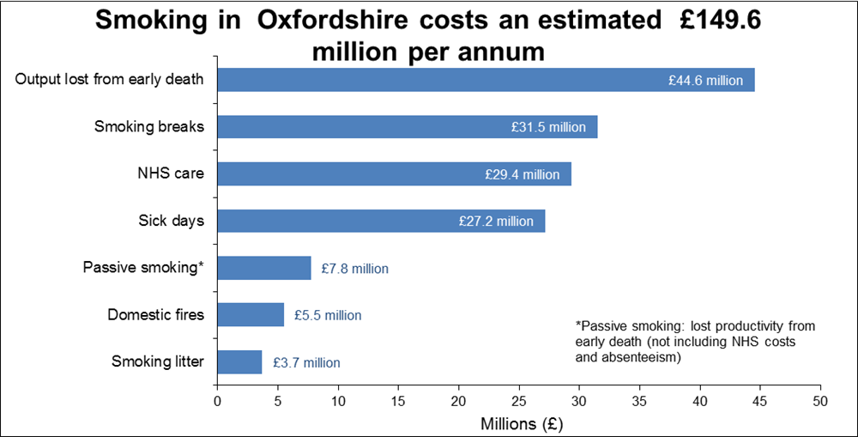

Although the prevalence of smoking is falling in the county and it is lower than national and regional rates, the benefits of stopping, or not starting in the first place, are still not being realised universally across the population.

The least well-off in our county are twice as likely to smoke that the most well-off, with 30% of routine and manual workers smoking compared to 14% of managerial and professional workers. Most smokers start before the age of 19 and studies consistently show that the largest influence on children’s smoking is whether or not their parents smoke. Reducing the prevalence of adult smokers will reduce the role-modelling effect, and prevent more young people from taking up the habit.

What are we doing about it in Oxfordshire?
- We continue to commission smoking cessation services from GP practices and community pharmacies which support and encourage people to quit and set ourselves tough smoking quit targets to reduce the number of adult smokers. In 2012-13, 3,703 smokers quit for at least 4-weeks.
- We have piloted a new outreach service to deliver smoking cessation consultation and support in community settings such as Templars Square in Oxford. This has been very successful at reaching communities at greater risk with 66% of quitters coming from target groups.
- We support annual campaigns such as Stoptober and No-Smoking Day in conjunction with trained smoking cessation advisors and providers of smoking cessation support in Oxfordshire.
- Smoking cessation specialists continue to deliver tobacco education, smoking cessation training and advice on tobacco control policy to staff and members of the public in schools and colleges, children’s centres and hubs, prisons and detention centres, mosques, inpatient and community mental health settings, in our hospitals and community hospitals, in learning disability settings, workplaces, military settings and many more.
- We continue to work with the council’s Trading Standards team to enforce statutory legislation such as underage sales and tackling smuggled and counterfeit tobacco.

In addition, it has never been easier for people to help themselves. Nicotine gums, tablets and patches are available in many shops and really help people to stop.

Recommended Next Steps
- The Health Improvement Board should continue to prioritise local action to reduce inequalities in smoking and smoking quitting rates.
- We will re-commission our smoking cessation services in the light of the experience gained above.
- We will experiment with more targeted ways to help ‘hard to reach’ groups.

Drug and Alcohol Addiction

Why is this important?
Drugs and alcohol consumption has a huge impact on the individual, on families, on communities and wider society. Problems with drugs and alcohol can lead to loss of employment, family breakdown and criminality, and these problems unfortunately affect us all.

It is vital that we provide information, advice, support and good quality effective treatment for young people and adults alike. This starts with good education within school and making sure schools have access to advice and support.

For adults, it is important that we have well thought through Public Health messages on safe drinking which steer a careful course towards informing and away from nannying.
We also need to provide sound advice, information, support and a range of treatment options for both drugs and alcohol and support for families and carers.
We need to make sure children of drug and alcohol addicted parents have support and access to the services they require.

It is also important that we meet new challenges, such as the challenge of new ‘psychoactive substances’ known as ‘legal highs’ which pose a significant threat.

- On average, 2600 individuals receive treatment for problems with drugs or alcohol over the course of a year in Oxfordshire.
- About 1600 of these individuals are addicted to opiates e.g. heroin.
- We support 800 people with alcohol problems and alcohol addiction
- In Oxfordshire services are good at getting people into treatment but need to be more effective in helping people to recover from addiction.

What are we doing about it?

- During the last year we increased drugs and alcohol education in every school in Oxfordshire. Each school now has access to high quality drug education and alcohol education.
- We have revamped the old ‘DAAT’ (drug and alcohol action team) arrangements now that the vast majority of funding sits in the Public Health Grant. The DAAT has been replaced by a multi-agency group advising the Public Health team.
- Parents’ and carers’ guides to drugs and alcohol are disseminated through every school- these are very helpful as parents need to keep up with the world of young people. They can be found at http://www.oxfordshiredaat.org/pdfs/PandC%20Guide%20NEW%20PROOF.pdf
- We have specialist drug and alcohol workers in every Early Intervention Hub in Oxfordshire.
- Oxfordshire has good specialist drug and alcohol treatment services across the county. These will be improved when the current contracts end in March 2015.
- Oxfordshire has its own specialist 10 bed residential detoxification service, (commonly called ‘drying out’) which gives good results – Howard House in Oxford.
- During the last year we have sustained investment in specialist residential rehabilitation (I.e. recovery after giving up) and residential detoxification through new contracts across the country.
- We have made sure that this work is an integral part of safeguarding work across the county.
- Oxfordshire is one of the few Counties where, in partnership with Trading Standards and the Police, we are meeting the challenging and new threat from New Psychoactive Substances or Legal Highs.
- All this will culminate in us producing a new specification for an improved service commissioned by the council. The new service will be up and running during 2015. Public consultation on options for doing this is currently underway.

Recommended Next Steps
- Complete a service specification for a new service as key contracts are due to expire at the year end.
- Ensure that these services will focus on getting people off drugs altogether.
- Continue to strengthen partnerships especially with GPs.
- Work with Public Health England to make sure Oxfordshire’s indicators improve.
- Begin to report progress on performance through the Health Improvement Board and through the Performance Scrutiny Committee.

Healthy Ageing

Why is this important?
When the NHS was founded in 1948, 48% of the population died before the age of 65; that figure has now fallen to 14%. In Oxfordshire life expectancy at 65 is now nearly 22 years for women and 19 years for men.

Life Expectancy at 65 years - Male 2000-2011 (3-year rolling averages)

Life Expectancy at 65 years - Female 1998-2011 (3-year rolling averages)

Many people stay healthy, happy and independent well into old age and there is mounting evidence that in the future older people will be more active and independent than today. However as people age they are progressively more likely to live with a medical condition, disability and frailty. In addition around one in ten people over 75 feel isolated and around one in five feel lonely.

A person’s health and well-being in later life are affected by many factors over the course of their life, such as education, housing and employment. Many organisations have a contribution to make and initiatives elsewhere in this report will affect people in older age, such as supporting people to maintain healthy weight, manage addictions and give up smoking. It is important that all services which promote healthy lifestyles are accessible to older people.

An important aspect of remaining healthy in old age is identifying health problems early or preventing them altogether. In Oxfordshire there is evidence that people are not making the most of opportunities available to them. For example:

- People aged 40-74 who have not already been identified with a health problem are invited for a health check once every five years. However less than half of the people, currently invited, take up this offer which could identify important health problems such as diabetes, hypertension or high cholesterol levels.
- Only 58% of people aged 60-69 and 56% of people aged 70-74 complete and return tests to check the risk of bowel cancer. Research shows that deaths from bowel cancer reduce by a quarter in those who are screened.
- Flu vaccination can save lives, it is important that people are vaccinated every year. Uptake in the over 65s in 2013/14 was 74.3%.

How does Oxfordshire compare with elsewhere?
In 2013 the Oxfordshire’s Older People’s Joint Commissioning Strategy 2013-16 was launched with a goal “To enable people to live independent and successful lives”. Both the Clinical Commissioning Group and Oxfordshire County Council signed up to promote healthy approaches to ageing including encouraging healthy lifestyles along with a focus on reducing ill health through early identification of problems. There was agreement to invest in community services to achieve better outcomes for people and reduce the need for hospital and inappropriate residential care.

The NHS Health check programme now includes brief advice for alcohol problems and help to detect dementia earlier.

The uptake of flu vaccination in Winter 2013/14 in the over 65s was 74.3% and in the under 65s at risk was 54.5%. The latter figure is a significant improvement on previous years and represents significant work across agencies to raise awareness and to target patients especially by the Clinical Commissioning Group.

The uptake of the NHS’s Bowel Screening programme has been identified as a Health and Wellbeing Board target, but unfortunately uptake has not shown the increase we had hoped. We will need to work with the NHS to improve this.

Despite these initiatives there is still much to do.
- We will have to find ways to help communities to help themselves, especially in our rural areas. This will be challenging as resources of the statutory sector are scarce.
- Loneliness remains an important challenge and affects older people across the board in both rural and urban areas.
- We need to build more dwellings suitable for old age – extra care housing is a good example of this. The supply falls well short of the demand.
- There are opportunities for Public Health to work more closely on the integration of adult social care and NHS services. Everyone acknowledges that services need to shift towards prevention and earlier detection of illness but we have a long way to go to make this a reality.
- The role of carers will remain pivotal and the emphasis on giving them more of the support they need and deserve is to be welcomed.
- The role of volunteers, the voluntary sector will be crucial as will the good work of churches and faith groups.
- We will need to continue the search to find new ways to work with citizens to help them reach a healthy old age and to be productive and active for as long as possible. The resources needed will be far more than the State can deploy and solving this conundrum remains our most pressing priority.

Recommended Next Steps
- We need to keep this issue high on the agenda of all statutory bodies including the Health and Wellbeing Board.
- We will join up our efforts more across Public Health the NHS and adult social care services to find new ways of preventing ill health.
- We need to work closely with the NHS, the voluntary sector, faith groups, carers, and Healthwatch to align and coordinate our efforts.
- We need to build on our ‘Community Information Networks’ – the current partnership with the Church of England is a very encouraging sign.

NHS Health Checks Commissioned by Oxfordshire County Council

Why is this important?
The NHS Health check is a national risk assessment and prevention programme required by statute. It is commissioned from the NHS by the county council. Health Checks specifically target the top seven causes of preventable deaths: high blood pressure, smoking, high cholesterol, obesity, poor diet, physical inactivity and alcohol consumption.

The programme requires us to invite all eligible individuals aged 40-74 years old for the check every five years (186,723 people), which means that 20% of this age group are invited per year. The age range is set nationally because it is the most cost-effective group in which to detect preventable disease.

In Oxfordshire, the Joint Health and Wellbeing Strategy set a target for 65% of those invited for NHS Health Checks to turn up for their checks. This is ambitiously higher than the national target. If we achieve this, based on Public Health England (PHE) modelling using the NHS Health Check Ready Reckoner, we could potentially:

- identify over 700 people who require anti-hypertensive drugs
- discover over 1000 people who require a statin
- detect over 200 cases of undiagnosed cases of diabetes and over 500 cases of kidney disease earlier, allowing people to manage their condition sooner and prevent complications
- refer over 2000 people to a weight management programme
- offer 7500 people a brief intervention to take up more physical activity
- generate over 550 referrals to smoking cessation services
- help reduce the increasing health and social care costs related to long term ill-health and disability

Currently, NHS Health Checks are delivered solely through GPs. During 2013/14, all 83 practices signed up to the NHS Health Check with 81 of them carrying it out. At the time of publishing this report, 81 GP providers have been contracted to carry out Health Checks for 2014/15 by means of an Approved Provider List. We cannot oblige GPs to do this: it is a commercial arrangement outside of their national contract. Cooperation with the Local Medical Committee (which represents GPs in Oxfordshire when contracting) remains very positive.

During 2013/14, Oxfordshire invited 22.2% (41,368) of the eligible population for an NHS Health Check, and 10.2% (19,001) attended; which equates to an uptake of 46%. This is against an expectation of 20% for invites and 65% uptake. As such, all of the eligible population received an invite, ranking us 2nd across Thames Valley (out of 8). More significantly, 7888 invited Oxfordshire residents did not have their NHS Health Check completed

This is because we deliberately adopted an ambitious target so that we aim high. Our results are comparable with the rest of the country, but we are not content with that and are looking for ways to do better..

The challenge now is to increase uptake. Successful implementation of the NHS Health Check is a key priority for the Health and wellbeing Board in pursuing its goal of 65% uptake.

What are we doing about it?
- We will work with Public Health England (PHE) to develop options for improving the NHS Health Check ‘brand’. This will include different approaches to getting people to turn up, including tailoring invitations to different groups and testing new bespoke campaigns, for example through local sports clubs such as Oxford United.
- For the first time we will investigate alternate approaches to commissioning the delivery of NHS Health Checks outside of GP settings, for example through pharmacies.
- If we do this it will be important to make sure our GPs get the results of the checks so that they can take necessary action.
- We will quality assure the programme to make sure it meets the highest standards.
- We will continue to work with our partners in Public Health England to support future research and evaluation of the NHS Health Check programme locally.
- We will aim to increase awareness of the programme through a ‘drip feed’ effect.

Recommended Next Steps
- The Health and Wellbeing Board should continue to prioritise NHS Health Checks
- Work with the Clinical Commissioning Group (CCG)to use NHS Health Checks as one vehicle to achieve its priority to ‘tackle health inequalities by offering targeted support to address lifestyle behaviours and choices’.
- Continued partnership working with the Local Medical Committee, CCG and primary care providers of the programme to achieve increased uptake and high quality.
- Continue to explore other innovative ways of delivering Health Checks.

A Joint Public Health Strategy Between Oxford University Hospitals Trust and the county council’s Public Health Team

Why is this important?
Large hospitals see many patients every day and the scope to improve their health as well as to treat disease is tremendous. This has long been a missing piece in the jigsaw of the county’s Public Health. Thanks to the willingness of Oxfordshire University Hospitals Trust (OUHT) and our Public Health trainees we now have the makings of a joint strategy for the first time. This work is overseen by the Health Improvement Board.
The potential is enormous as there are 11,000 staff and over a million patient contacts each year at the Hospital Trust.

This Strategy sets out three major areas of work:

- To build capacity to promote healthy lifestyles to patients, visitors and staff at every opportunity.
- To develop a health promoting environment.
- To embed Public Health approaches within the Trust.

What are we doing about it?
A Steering Group for completing and implementing the action plan is being convened. Early work will include
- Staff training on Health Improvement to become Health Champions through accredited schemes
- A one year pilot of a Health Improvement Clinic for outpatients, family members and staff to get brief advice and to ‘signpost’ them to relevant local services
- Improving the availability of healthy food in hospital premises and looking for opportunities to increase physical activity.

Recommended Next Steps
- Consider the progress made in the first year and work with OUHT to build on this.
- Ensure that campaigns being coordinated across the county are also rolled out in the hospitals if appropriate in order to reach a wider audience.
- Support the OUHT in establishing its own permanent Public Health presence within the Trust.

Reducing Inequalities in Health

Good health is not experienced evenly or equally by all the people of Oxfordshire. This section looks at some of the causes of health inequality and reports on progress made.

The Thriving Families Programme

Why is this important
In last year’s Annual Report I described this programme in detail. This year I will concentrate on new achievements and future direction.

Thriving families is part of Oxfordshire’s long term priority to identify the families who need help the most and who consume a significant resource from social services, schools, the NHS, the Police and other agencies. The aim of the programme is to work closely with the families to turn this situation around.

Our programme is bearing fruit and is highly rated by the Department for Communities and Local Government and we are one of the top ten programmes in the Country.

The achievements of the programme can be set out as follows:
- We have identified 90% (around 700) of families expected by Government to be living in the county
- We are working with 70% of the identified families
- We are improving the lives of around 62% of the Thriving families in practical ways
However the real strength of our approach is that we are identifying families from every community in the county, urban and rural, and this makes the programme unique.
Innovations introduced during the year have been to:

- Work together with Jobcentre Plus to get people back into work.
- Expand the original programme (which focussed on anti-social behaviour, unemployment and poor school attendance) to look at ways to tackle mental health problems, drug addiction problems and domestic violence.
- Working with GPs to ‘flag’ family members so they can get extra support.
- Working with Public Health England to look at early indicators that might move us from ‘treatment’ of the problems to prevention.
- Using our database to evaluate and ‘cost’ the savings made.
- Using the experience to influence the development of all our children’s services across the board.

Recommended Next Steps
- Continue the core work of this programme.
- Learn from the experience of the last two years to help shape the children’s services of the future.
- Make closer and concrete links with the Clinical Commissioning Group.
- Evaluate the programme.
- Find ways of identifying families earlier so that we can begin to prevent problems arising.

A multi-ethnic Oxfordshire

Why is this important?
The last Census showed that Oxfordshire now has significant ethnic minority populations.
I discussed this issue extensively in my last annual report and will only mention the topic briefly here to ensure that the issue is not lost and that services continue to respond to this issue.
The headlines are:

- The county has a substantially increased ethnic mix compared with 10 years ago. Ethnicity doesn’t necessarily equate with disadvantage, and the needs of different communities will differ widely – the needs of Polish, Lithuanian or Czech economic migrants are unlikely to be the same as a first generation Asian immigrant for example.
- However, ethnic minorities, especially those who are fleeing persecution and those who do not speak English well do suffer health inequalities.
- There has been an ‘across the board’ increase in residents from ethnic minority groups of 57% on 2001 figures involving every district of the county.
- There has been an increase of 46,000 residents from all ethnic minority groups over the last 10 years.
- Over a third of all city residents are from ethnic minority groups and over 10% of all Cherwell residents.
- Some of our schools are now teaching children whose first language is not English and the number of first languages spoken may be over 20 languages.

Recommended Next Steps
- Continue to monitor the changing ethnic composition of the county through the Joint Strategic Needs Assessment in detail.
- Use this information to predict health risks more accurately across the county and build this into the plans of all organisations
- Make recommendations for services based on this analysis.
- Continue to press for better recording of ethnicity by GP practices.
- Support the Clinical Commissioning Group’s proposed Health Inequalities Commission to find practical ways to reduce these inequalities.

People with deafness and hearing loss

Why is this Important?
Recent reports have shown that deafness and hard of hearing are a ‘hidden’ health inequality. A report published by Signhealth (the Deaf Health Charity) includes results from a survey of 533 deaf people and health assessments of 300 deaf people, plus in-depth interviews with 47 deaf people. Their findings include:

- 62% of deaf people diagnosed with high blood pressure are likely not to have it under control compared with 20% of the general population.
- 70% of deaf people who hadn’t been to their GP recently had put off going as there was no interpreter. Expecting a deaf patient to lip read or writing things down for them is not considered a “reasonable adjustment” for their disability.
- 80% of deaf people want to communicate using British Sign Language but only 30% get the chance.

A report from Deaf Direct written for Oxfordshire County Council highlighted the increase in numbers of deaf people, partly reflecting the aging population but also due to other factors. Their work highlighted:
- Deaf people tend to have worse overall health and report poorer physical health and mental wellbeing
- 63% of people with hearing loss are aged over 65.
- 70% of over 70s have hearing loss and 40% of those aged over 50
- 8% have severe or profound hearing loss.
- In 2012 there were 557 children in Oxfordshire receiving a service from the Education Hearing Impaired Service. Many have additional needs.
- It is estimated that the number of deaf or hard of hearing people will increase by 14% every 10 years.
- Migration patterns may also mean increases in those who use sign language of their native country

What Are We Doing About It ?
Current services include:
- Audiology (private or NHS) for those with hearing loss.
- A sign-language service to allow parents to communicate with their children.
- Cochlear implants for children who are profoundly deaf.
- A newborn hearing screening programme which identifies hearing loss at birth and ensures aids/cochlear implants prior to children developing speech and language skills which enables children to enter mainstream schooling. This service is highly rated.
- Interpretation services commissioned by health and social services available for individuals when they see doctors etc.
- Advice and information services through the voluntary sector e.g. Deaf Direct.

Recommended Next Steps
- We should take this work in stages. The first step is to acknowledge the issue more widely and report accurate figures in our Joint Strategic Needs assessment.
- Work with the Clinical Commissioning Group to consider how this inequality might be tackled in practical terms. A key theme will be improved awareness raising about the options already available.
- More work to identify the needs of deaf people more carefully in care pathways and ensure that they have access to services.

Young Carers

Why is this important?
Children and young people who also have a caring role need extra support so that they will not experience poorer health and wellbeing than their peers. Services in Oxfordshire are of high quality. The need has been well recognised and action is being taken. This should continue.

Oxfordshire County Council has a dedicated Young Carers Team, committed to working with partner agencies, to identify and support this large vulnerable group of children and young people, and their families.
The council’s Young Carers Service works with 0-25 year olds, providing a range of support to the young carers identified in the county dependant on their assessed and identified needs. Approximately 1600 young carers are identified at present. The Carers’ Strategy can be found at https://www.oxfordshire.gov.uk/cms/content/oxfordshire-carers-strategy-2013-2016 - The Young Carers Service performance is reported to the Oxfordshire Health and Wellbeing Board.

This is important because the impact of being a young carer affects every facet of one’s life from social activities to future education and career prospects.

The County Council should be proud that The Carers Trust has commented that Oxfordshire has the "perfect model for delivering positive outcomes for young carers". The Carers Trust and the Department of Health recommend our work nationally as an example of best practice.

The number of young carers being identified in the county is increasing year on year. In 2012 we had 850 young carers on record and as of April 2014 we have 1541 young carers on record. This shows we have identified 371 new young carers in 13/14; a percentage increase of 31.7%.

The main cause of caring is parental mental health (23.4%) followed by sibling learning difficulties (18.0%) and parental physical disabilities (15.5%). 15.1% care for a parent with a physical illness, 13.6% for parents with multiple conditions and 8.8% for siblings with physical disabilities. 4.3% care for parents with substance misuse issues.

Educational Attainment
Our data shows us young carers are not achieving at GCSE in comparison to their non-caring peers. The reasons for this are complex. It does not necessarily mean that being a young carer is the only reason for the poorer attainment.

To address this, the Young Carers Team and Spurgeons Young Carers Project work with schools helping them to achieve our Young Carers Schools Standard Award which is a support package for schools to enable a whole school approach in the identification and support for young carers with a view to addressing issues of poor attainment and attendance.

Mental Health
A Young Carers Health Nurse post has been established, to better understand the health needs of young carers in the county. Early finding from this work show that many young carers are presenting with risk factors for their own mental wellbeing (feeling low, stressed, exhibiting risk taking behaviour's, self-harm and eating disorders). This work is being shared with the leads for School Nursing at the Department of Health to inform national practice development.

Recommended Next Steps
- The Young Carers team have a sound plan in place and this should be supported by all agencies. The number of young carers identified should continue to increase year on year.
- As well as maintaining the current service we should work with the NHS more on inpatient services helping them to 'Think Young Carer' from admission to discharge.
- We should also focus more on NHS primary care and community teams helping them to 'Think Young Carer' in their service delivery.
- We need to ensure that our new School Health Nursing service plays its part in improving the lot of these young people as it develops.

Infectious and Communicable Diseases

Why is this important?
Communicable diseases can have a major impact on the health of a population. A communicable disease is one which spreads from person to person through the air, water, food or by person-to-person contact.

Over recent years, most of the major killer infectious diseases have been in decline across Oxfordshire. However, these diseases remain a threat but their impact can be reduced further by good surveillance and information, early identification and swift action basic cleanliness, hand washing, practising safe-sex and good food hygiene.

General Infectious Diseases

Health Care Associated Infections (HCAIs)
Infections caused by superbugs like Methicillin Resistant Staphylococcus Aureus
(MRSA) and Clostridium Difficile Infection (CDI.) remain an important cause of sickness and death, both in hospitals and in the community. However numbers of infections continue to have been reduced through considerable focussed effort in this county.

Methicillin Resistant Staphylococcus Aureus (MRSA)
MRSA is a bacterium found commonly on the skin. If it gains entry into the blood stream (e.g. through invasive procedures or chronic wounds) it can cause blood poisoning (bacteraemia). It can be difficult to treat in people who are already very unwell so we continue to look for the causes of the infection and to identify measures to further reduce our numbers. MRSA has fallen gradually in Oxfordshire in response to the direct measures taken by hospital and community services to combat it (fig 1).

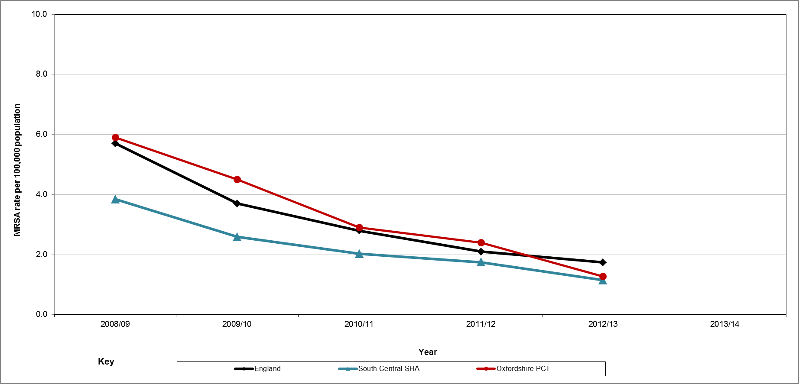
Fig 1. Methicillin Resistant Staphylococcus aureus (MRSA) - crude rate per 100,000 population (2008/09 - 2012/13) England, South Central SHA and Oxfordshire

This shows that infectious diseases can be tackled, often by traditional hygiene measures. Nationally there is a zero tolerance policy and the rate of MRSA is still higher than we would like. There have been improvements in the rate of MRSA in Oxfordshire over the past few years from being above the national average to moving below the average.

Clostridium difficile infection (CDI)
Clostridium difficile is a bacterium that causes mild to severe diarrhoea which is potentially life-threatening especially in the elderly and infirm. This bacterium commonly lives harmlessly in some people’s intestines but commonly used broad spectrum antibiotics can disturb the balance of bacteria in the gut which results in the bacteria producing illness.

A focussed approach on the prevention of this infection is resulting in a steady reduction in cases since 2007/08 (fig 2) in line with regional and national trends. However, whilst there has been an improvement in the rates of CDI in Oxfordshire, it is still above National and Regional levels of infection.

The reduction in CDI involves the coordinated efforts of healthcare organisations to identify and treat individuals infected with CDI and also careful use of the prescribing of certain antibiotics in the wider community. There are on-going concerted efforts locally to continue to improve the rate of CDI.

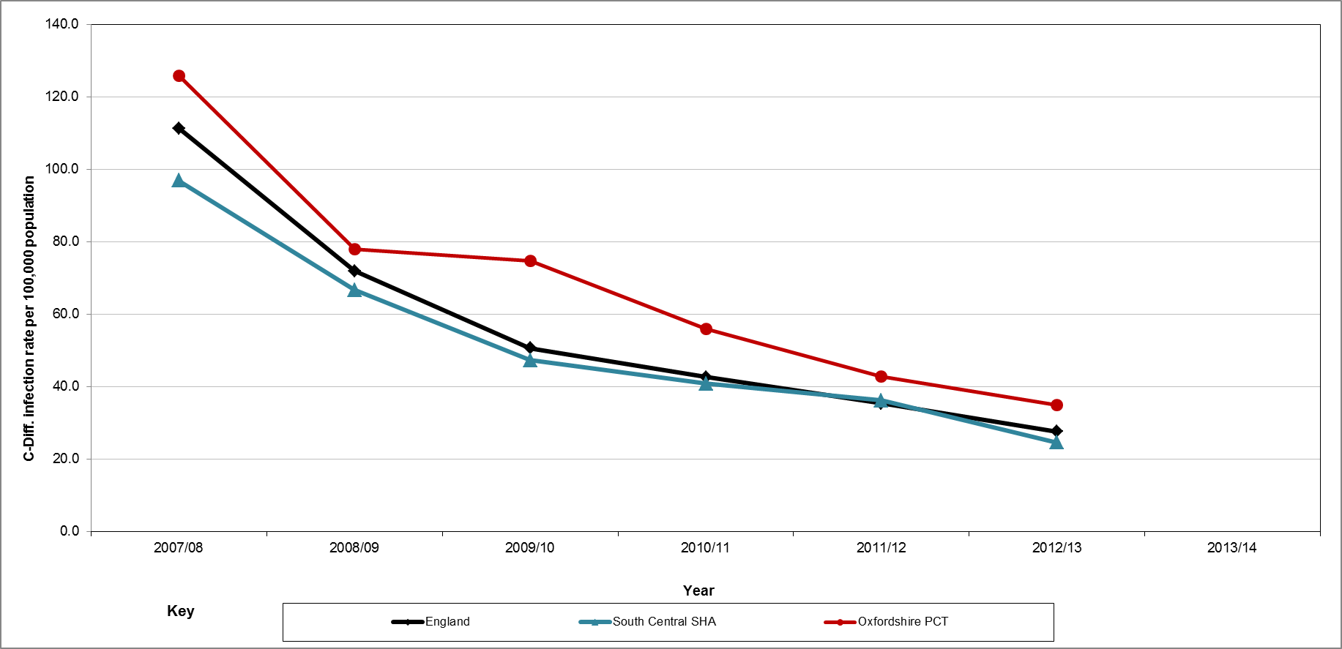
Fig 2. Clostridium Difficile Infection (CDI) - crude rate per 100,000 population (2007/08 to 2012/13) England, South Central SHA and Oxfordshire PCT

Tuberculosis (TB) in Oxfordshire
TB is a bacterial infection caused by Mycobacterium Tuberculosis which mainly affects the lungs but which can spread to many other parts of the body including the bones and nervous system. If it is not treated, an active TB infection can be fatal as it damages the lungs to such an extent that the individual cannot breathe.

In Oxfordshire the numbers of cases of TB at local authority level are low. A three-year average is given which shows that the case rate is fairly static (Fig 3).

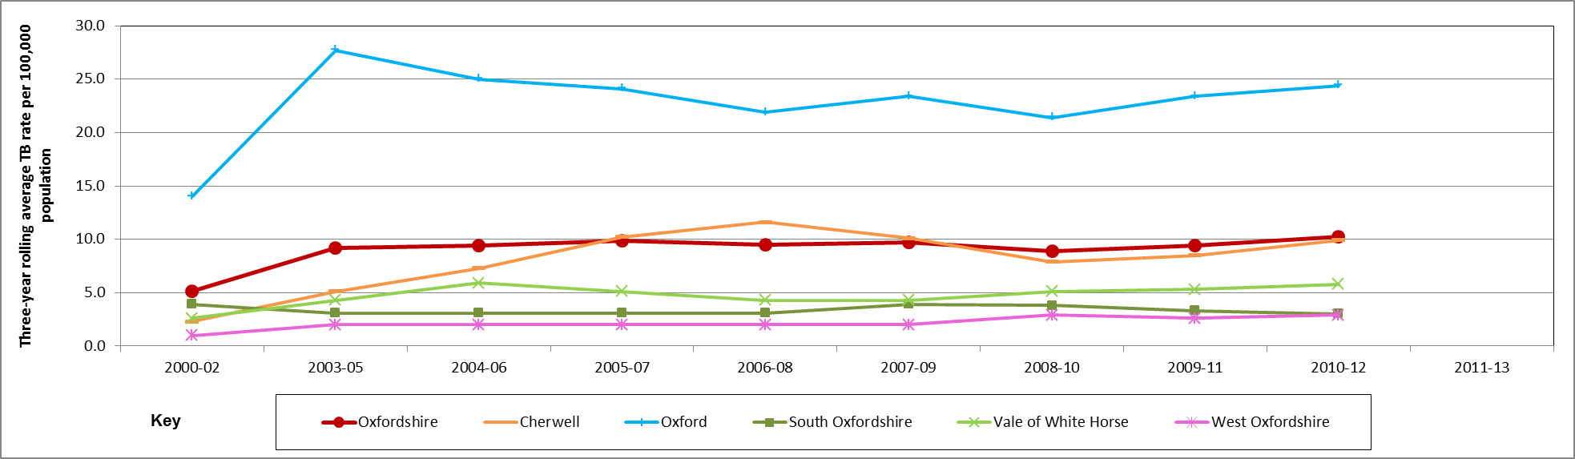
Fig 3. Tuberculosis (TB) - Rate per 100,000 population (2004 to 2012) Oxfordshire and districts within Oxfordshire

The levels of TB in the UK have stabilised over the past seven years. However, despite considerable efforts to improve TB prevention, treatment and control, the incidence of TB in the UK is higher compared to most Western European countries.

The rate of TB in Oxfordshire is lower than National and Thames Valley PHE Centre levels (covering Oxfordshire, Buckinghamshire and Berkshire). In the UK the majority of cases occur in urban areas amongst young adults, those coming in from countries with high TB burdens and those with a social risk of TB. This is reflected in the higher rate of TB in Oxford compared to other districts in the county.

TB should not be underestimated and has not gone away. Recent experience has shown that resistant strains of TB can spread rapidly from person to person through ordinary social contact.
Given the importance of TB, it is one of the key priorities of Public Health England who are working to support local services.

Recommended Next Steps

The Director of Public Health should report infectious diseases in subsequent annual reports.

Sexually Transmitted infections

It is vital that we maintain and improve services to prevent and treat sexually transmitted diseases. These will not go away and we need to keep up our vigilance, especially as these services are now spread over a wide range of agencies. The county council has several roles in this. Firstly a watchdog role to ensure that all services are good, a commissioning role as a major commissioner by statute of these service, and lastly a partnership role, playing our part to make services work smoothly together.

HIV & AIDS

HIV remains a significant disease both nationally and locally. During 2011, Oxfordshire saw a drop in the number of new diagnoses. There are now approximately 450 people living with HIV in Oxfordshire (fig 4). We would expect the chart to show an upward trend because people are now living longer with the disease and so the number of people will ‘accumulate’. The national report 'HIV in the United Kingdom: suggests that a quarter of people with HIV have yet to receive a diagnosis. In Oxfordshire, this equates to another 112 people bringing the total estimated cases for Oxfordshire to 562.

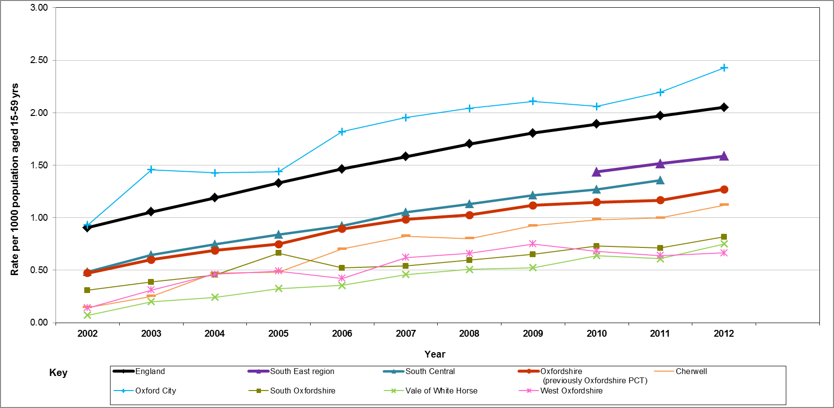
Fig 4. Prevalence of diagnosed HIV per 1000 population (i.e. people living with a diagnosis of HIV) aged 15-59 years England, South East region, Oxfordshire and Oxfordshire districts

Finding people with HIV infection is important because HIV often has no symptoms and a person can be infected for years, passing the virus on before they are aware of the illness. Trying to identify these people is vital. We do this in three ways:

- Through antenatal screening programmes - There are approximately 7,000 deliveries per year in Oxfordshire and 99% of pregnant women are screened for HIV, this identifies an average of 9 women as being HIV positive per year.
- Through routine testing at our sexual health clinics.
- Through community testing, we have introduced 'HIV rapid testing' in a pharmacy as an initial step. This test gives people an indication as to whether they require a full test; the rapid test takes 20 minutes and gives fast results, although a fast tracking to the sexual health service for a full test is required to confirm diagnosis.

HIV is now considered to be a long term disease and prognosis, once diagnosed, is good, with effective treatments. HIV cannot be cured but the progression of the disease can be slowed down considerably, symptoms suppressed and the chances of passing the disease on greatly decreased.

Sexual Health

Sexually Transmitted Infections (STIs) are continuing to increase in England with the greatest number of cases occurring in young heterosexual adult men and women and men who have sex with men. STIs are preventable through practising ‘safe sex’. Total rates of STIs in Oxfordshire are below the national average except in the city which is a reflection on the younger population who live there (fig 5).

The increase in the rates in the city can be attributed to a combination of factors. There is a large student population and higher proportion younger people living in the city who have been targeted for Chlamydia and STI testing. This increases the number of cases found which is a good thing. Similarly there have been increased diagnoses of Gonorrhoea due to improved testing methods. This is also good news. The keys to fighting these infections are:

- Use safe sex methods and don’t get the disease in the first place – and this applies to all age groups
- Find and treat the disease fast to prevent the spread

The different main types of STI each show a mixed picture which is generally good. Looking at each disease in turn gives the following picture:

- Gonorrhoea – is below national average for Oxfordshire as a whole and all districts except in Oxford city. This follows a typical ‘urban’ profile of higher levels.
- Syphilis - is falling and below national average in all areas of the county except in Oxford city.
- Chlamydia –levels are lower than national average – but we continue to have difficulties in persuading young people to come forward for testing despite, best efforts.
- Genital Warts – rates are now lower than national average which is an improvement. Oxford city is significantly higher (reflecting the younger age group) but the trend is generally stable.
- Genital Herpes – rates are lower than national average except in the city which has higher levels. However the total number of cases in the year is small. Again this reflects the predominantly younger population in the city.

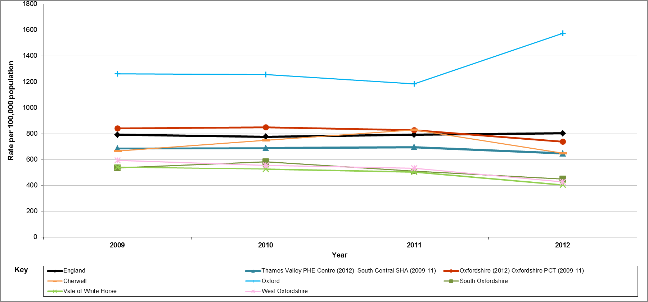
Fig 5. Rate of diagnosis of acute sexually transmitted infections (STIs) per 100,000 population (all ages) - 2009 to 2012 England, Thames Valley Public Health England Centre, Oxfordshire and districts within Oxfordshire

This year Oxfordshire County Council has commissioned an integrated sexual health service as part of a network of NHS, Public Health England and Local Authority services which prevent and treat STIs. We need to fine –tune the service along with all others in the light of changing disease patterns and make sure that services in the city are working well.

Recommended next steps
- Ensure the successful implementation of the new integrated sexual health service and monitor the service closely and adjust it if necessary.
- Monitor all services in the city closely across general practice, pharmacies, school health nursing, sexual health clinics and the sexual health service HQ at the Churchill Hospital. Take any action needed in the light of this monitoring.
- Continue to prioritise and target young people and vulnerable groups in promoting safe sex awareness.

